EVALUATION OF REGRESSION AND CLASSIFICATION MODELS :

REGRESSION EVALUATION METRICS :

MOTORBIKE PREDICTION MODEL :

1. I used the hour.csv dataset for building this prediction model since it has more number of data than the day.csv dataset.
2. The string values in the dataset are converting into the numeric values using labels.
3. Using train_test_split method , the dataset is splitted into training set and testing set.
4. By using the Linear Regression algrorithm the model is predicting the output with the test dataset.
5. The Mean Square Error, Root Mean Square Error and R2 Score are determined with the test set and predicted value.

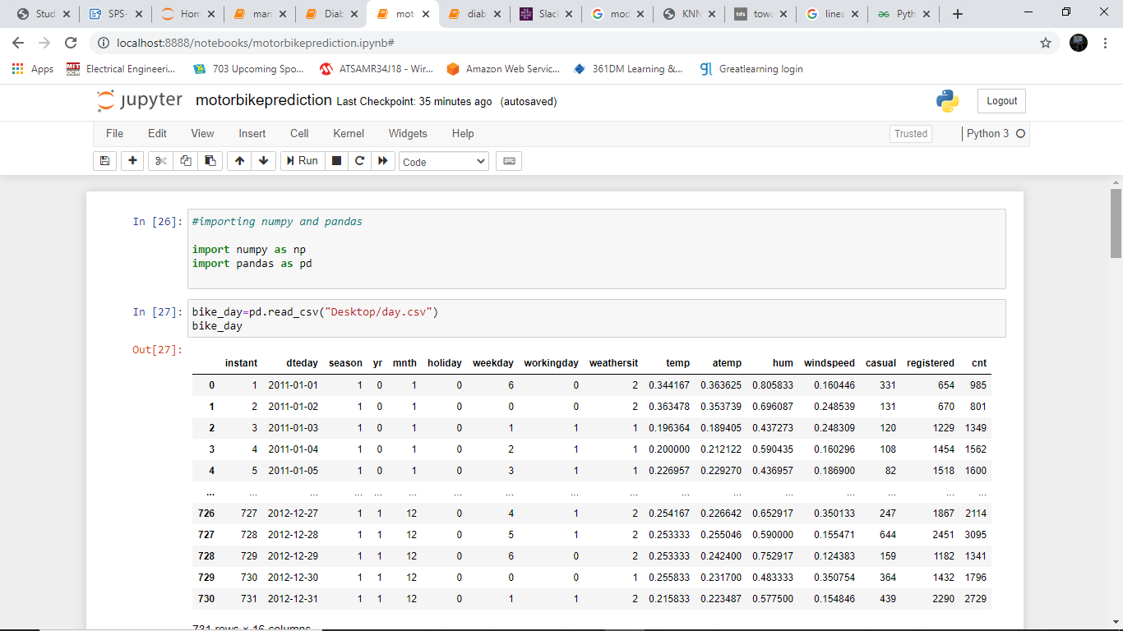

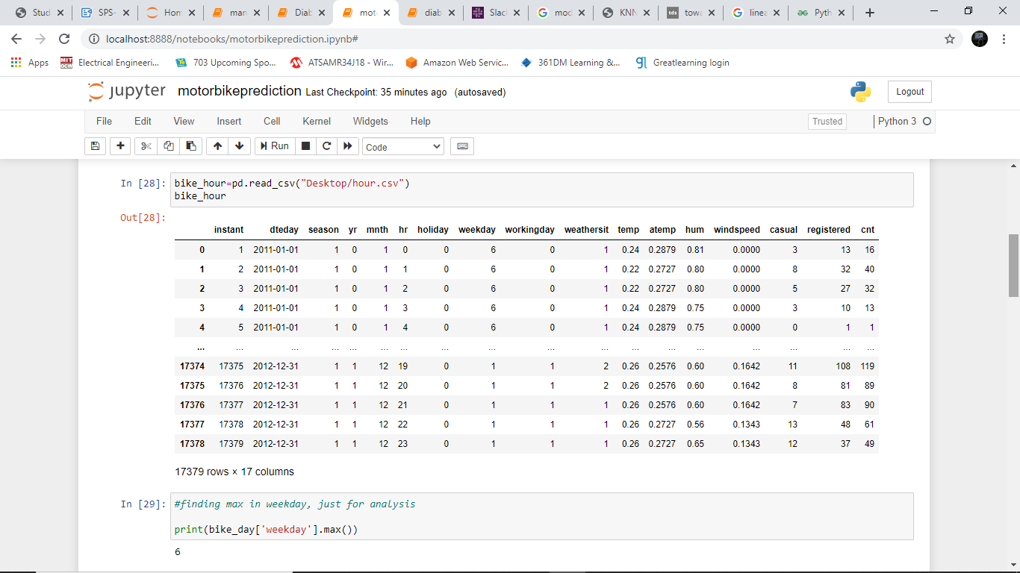

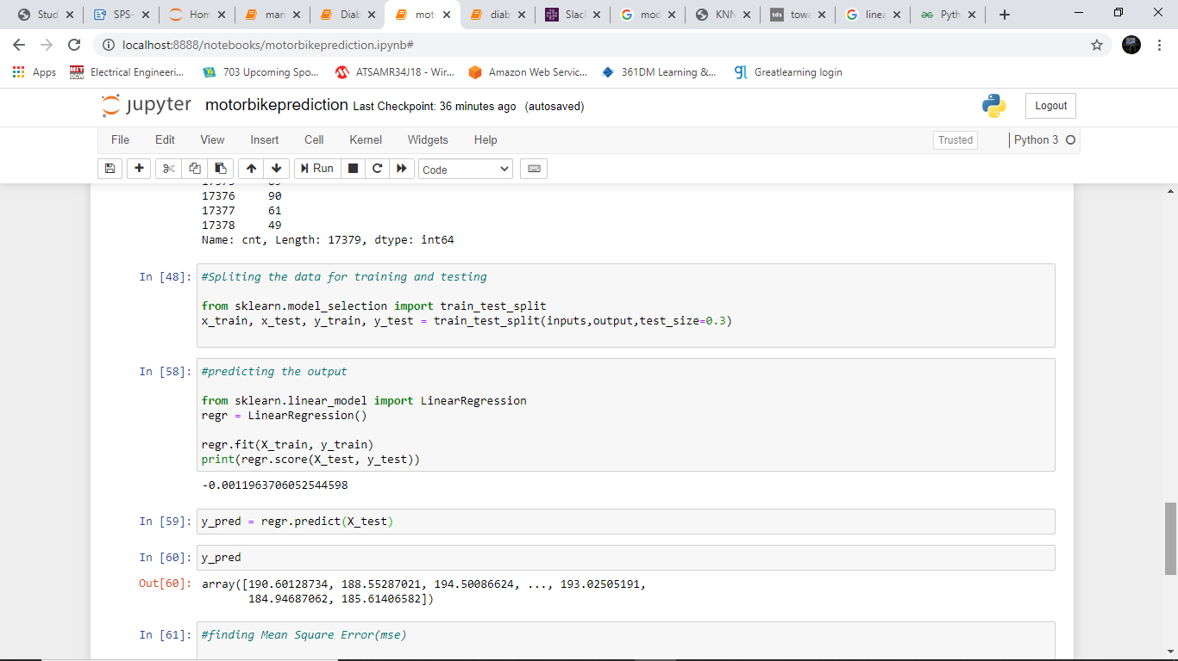

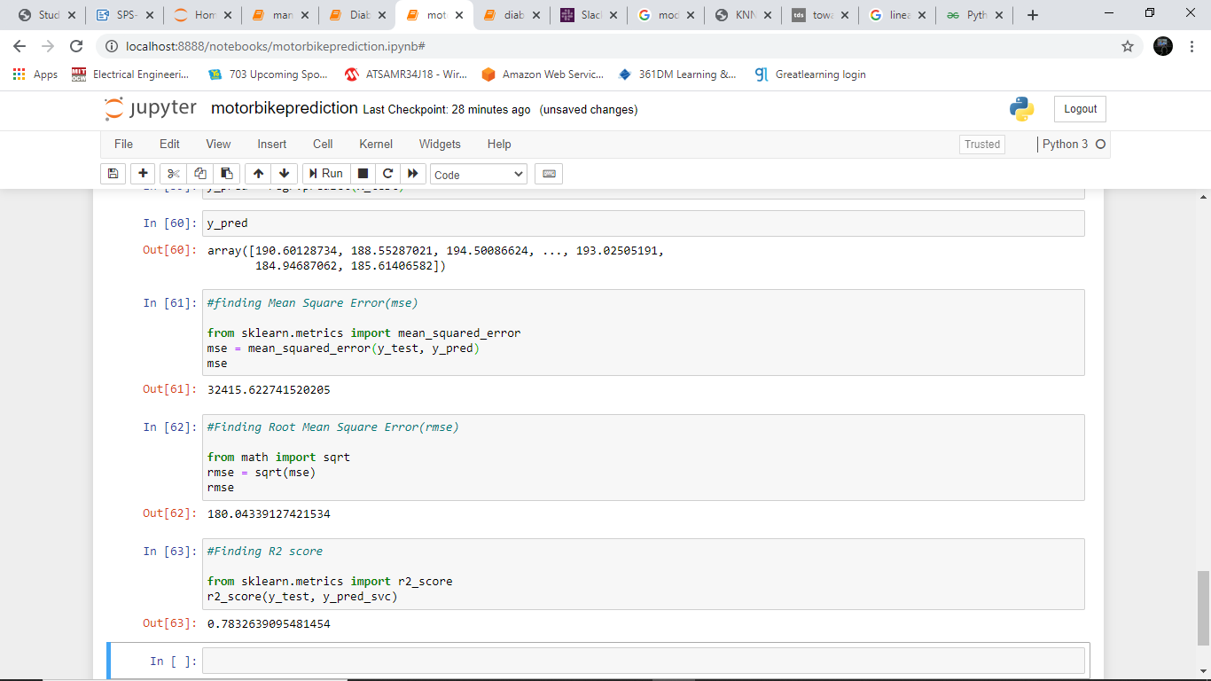

CLASSIFICATION EVALUATION METRICS :

DIABETICS PREDICTOR :

1. The diabetes.csv dataset is used to train the model using the K-Nearest Neighbour (KNN) algorithm.
2. The string values in the dataset are converted into numneric values using labels.
3. The dataset is splitted into training and testing dataset using train_test_split method.
4. By using the KNN algorithm the values are set and the output is predicted.
5. The classification evaluation metrics such as Accuracy score, confusion matrix and AUC-ROC curve are plotted.

